RMS Documentation

This project has purpose of booking system for Indian Railways, we assure that each passenger should get a smooth experience with our application. Our aim is to provide user-friendly environment on our application.

Our team chosed design first approach, we surfed the internet to get the idea for application. We worked as a team and collaborated in each problem ever came. Time management was our first priority.

Problem Solution

Our faculty helped us through out the project, we learned a lot from this and we are confident to face upcomming projects. Problems occurred while we were making logics for booking system, but the end we learned and did it.

Our team

1. Muhammad Jihad Ejaz (Student1364078)
2. Muhammad Hussain (Student1359428)
3. Muhammad Usama Riaz (Student1365919)
4. Muhammad Anus Ghouri (Student1365966)

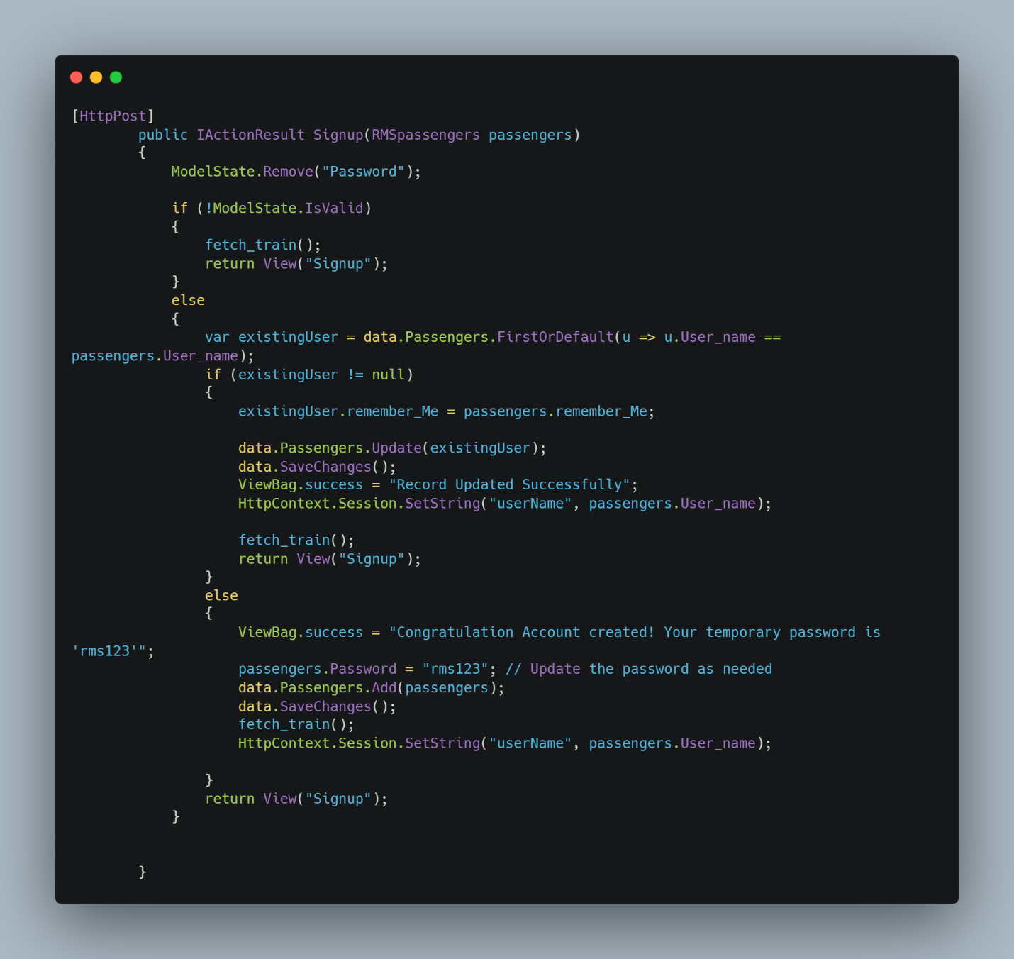

Signup Code

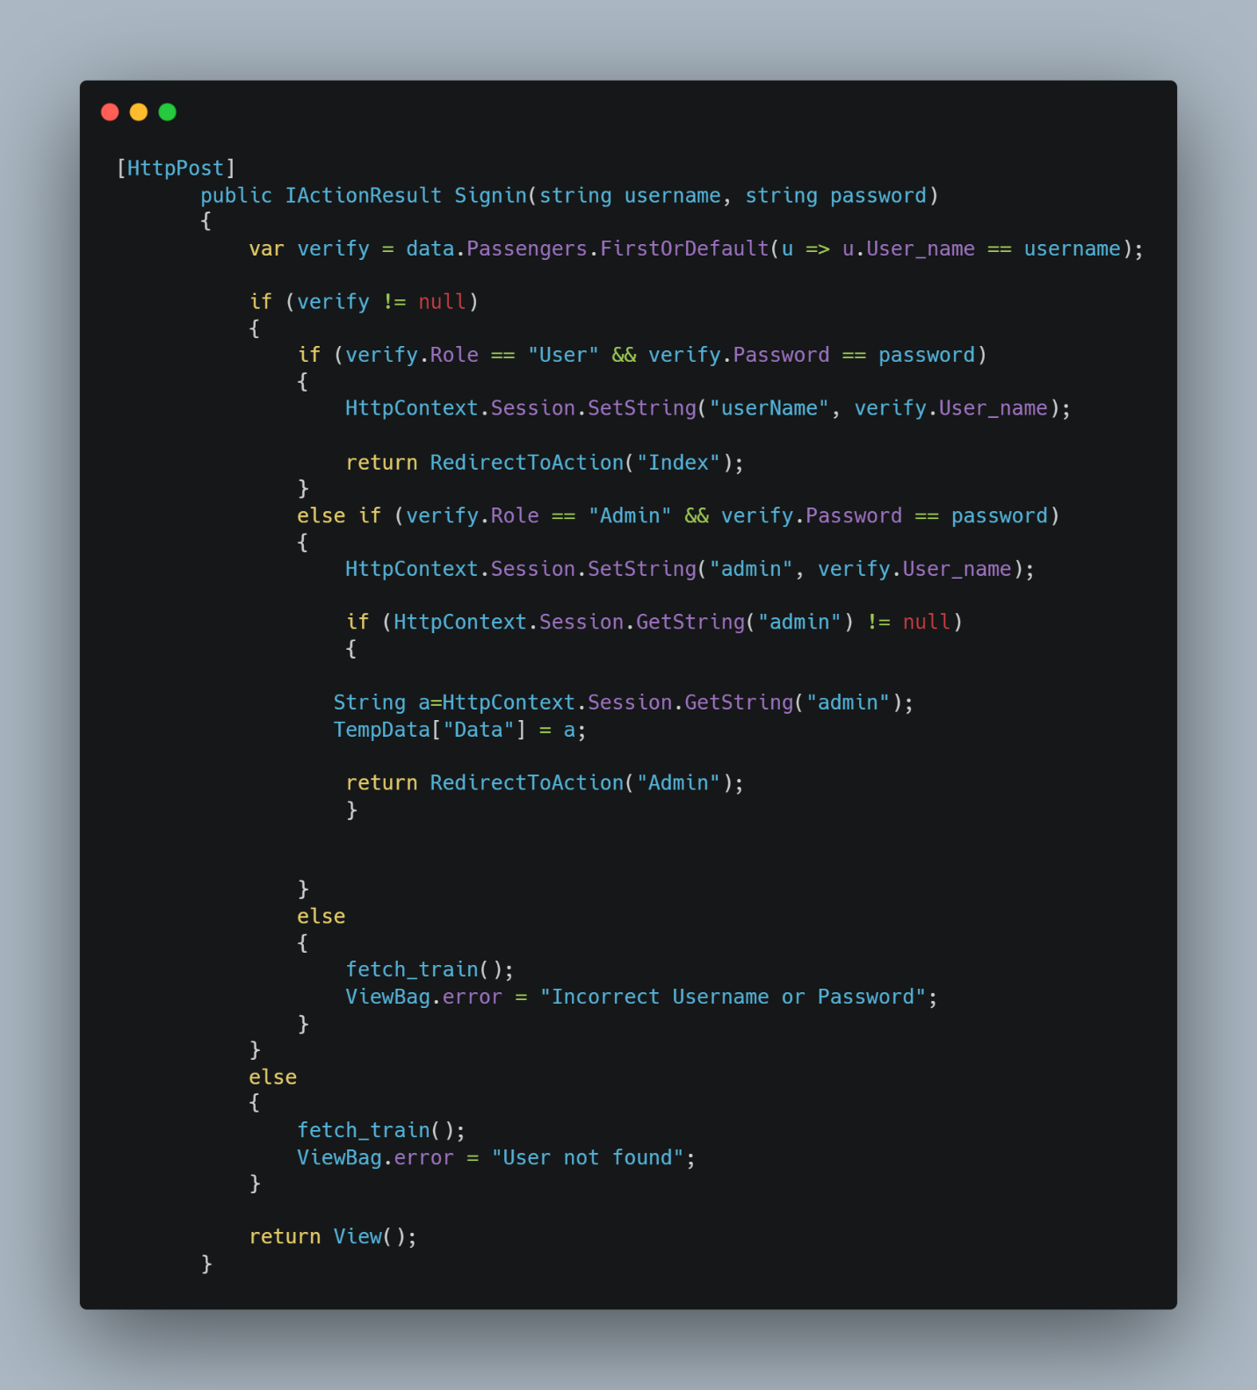Sign in Code

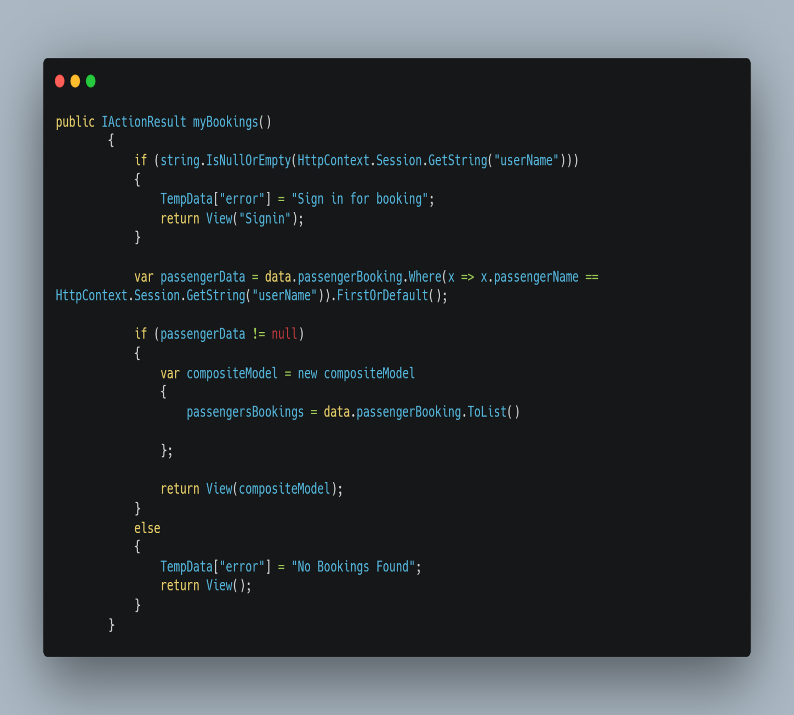

myBookings Code

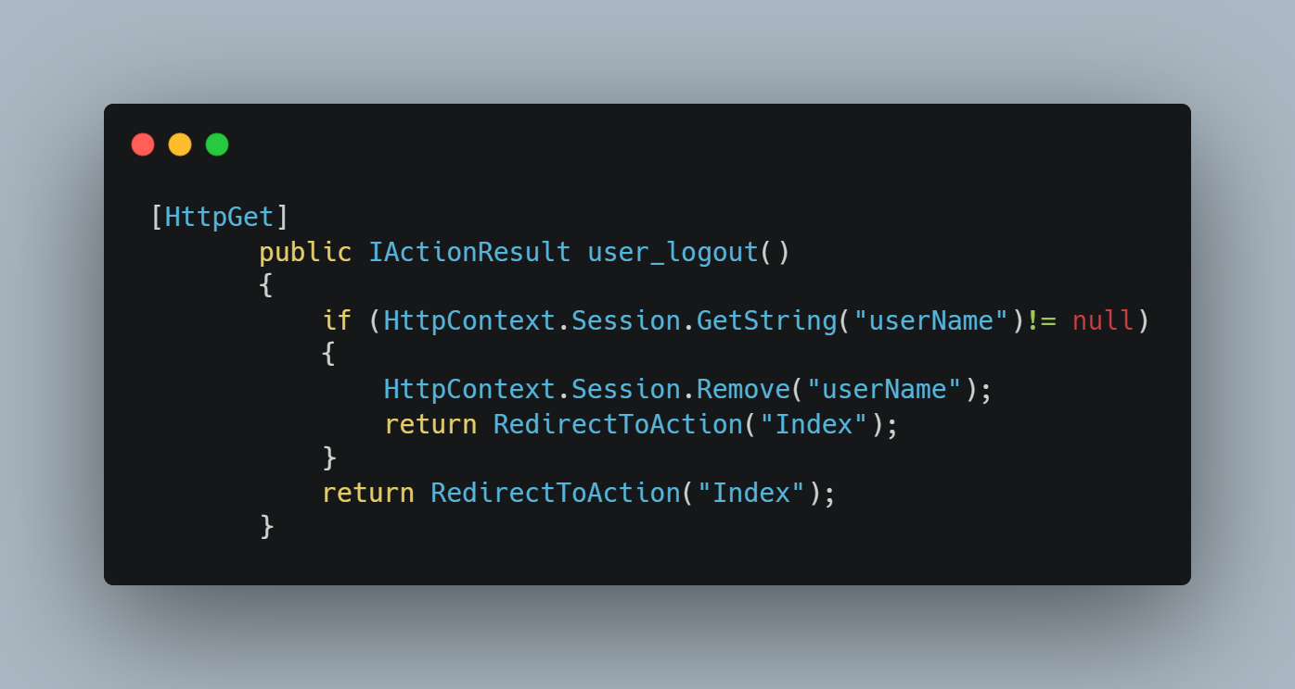

User logout Code

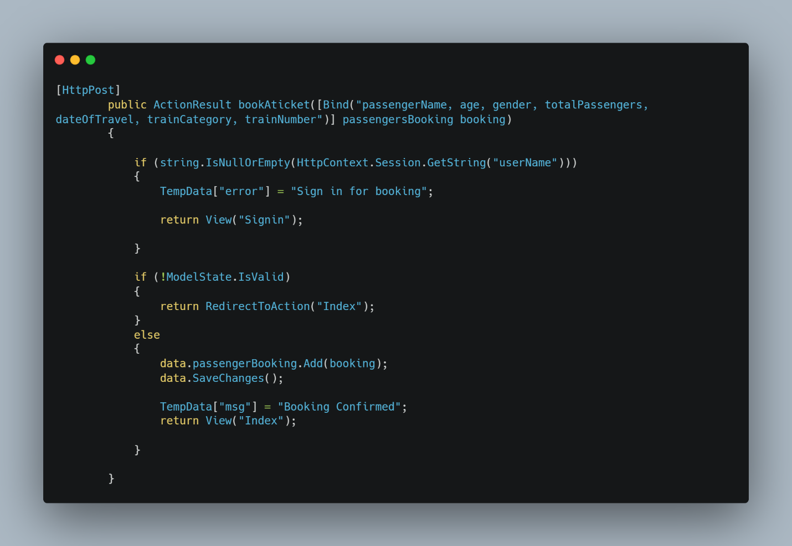

Book a ticket Code

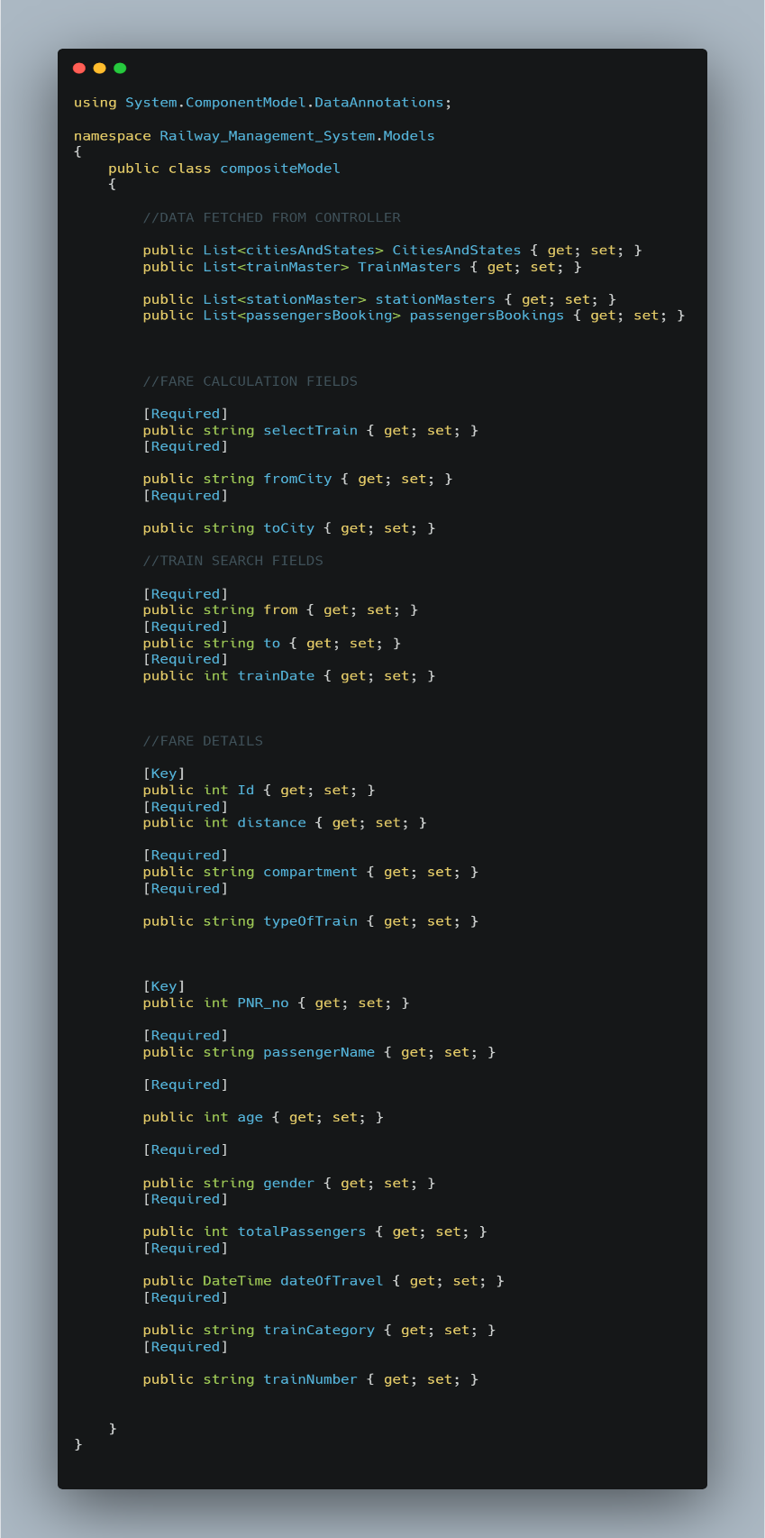

Composite Model

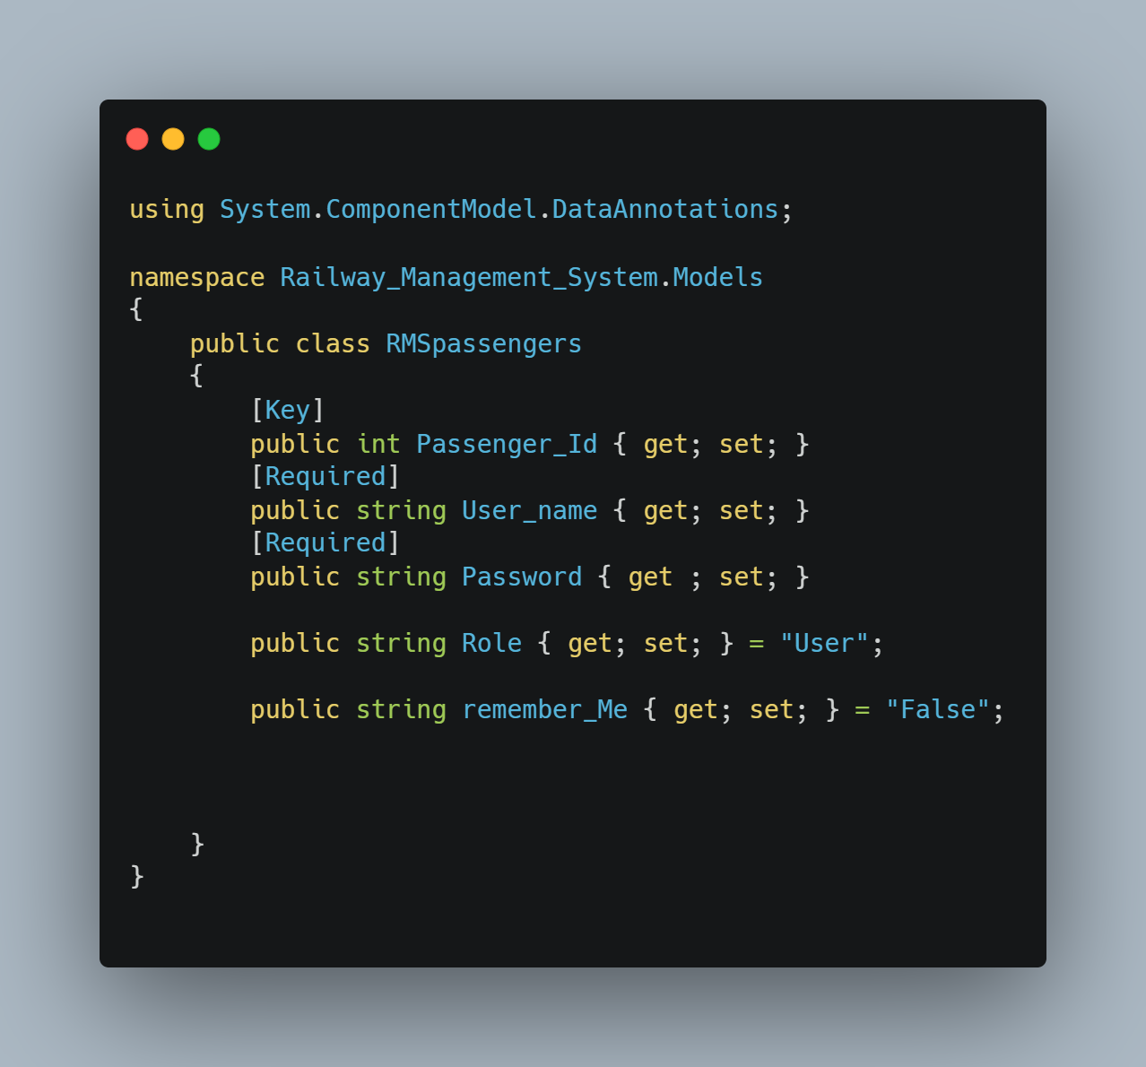

Passengers Details

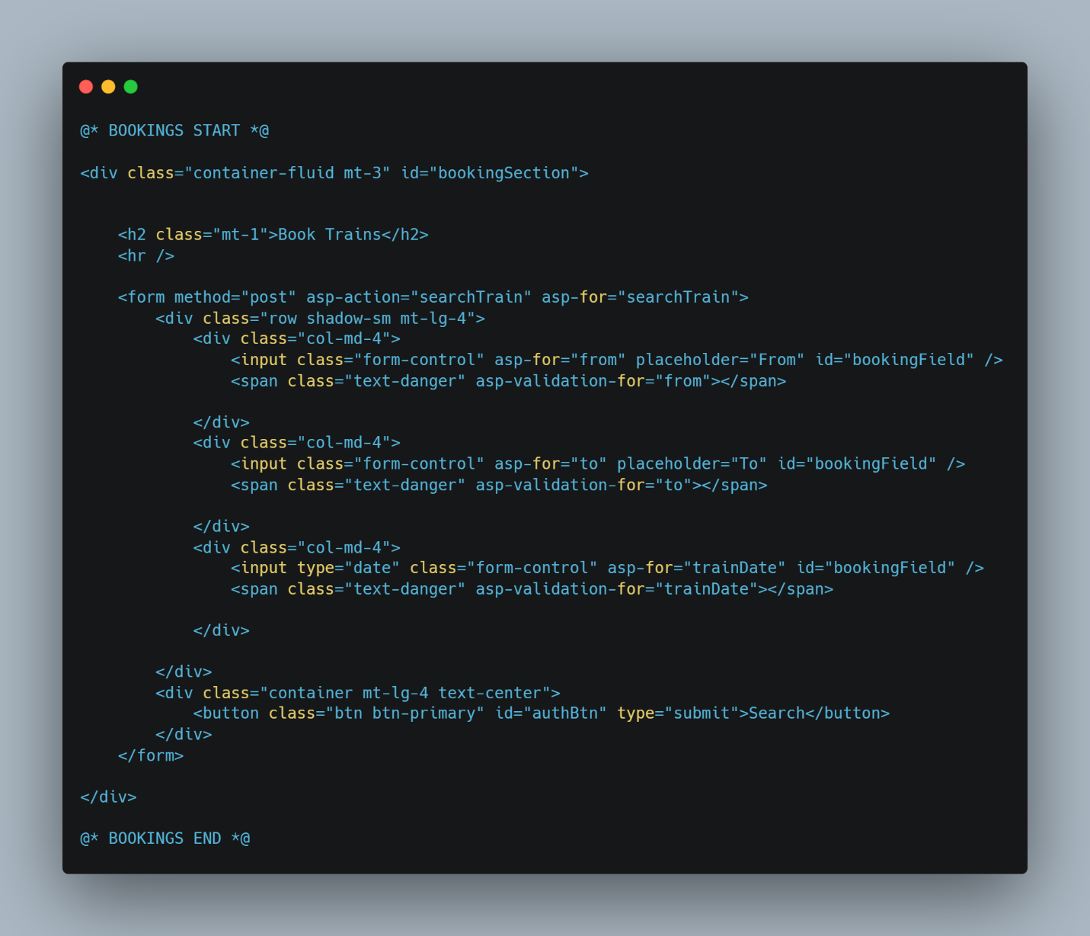

Booking form Layout

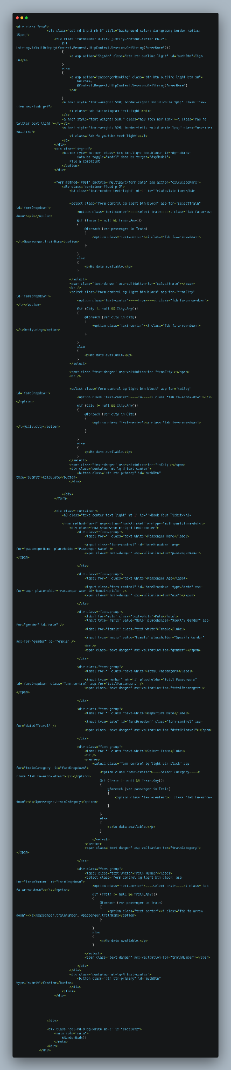Shared layout page

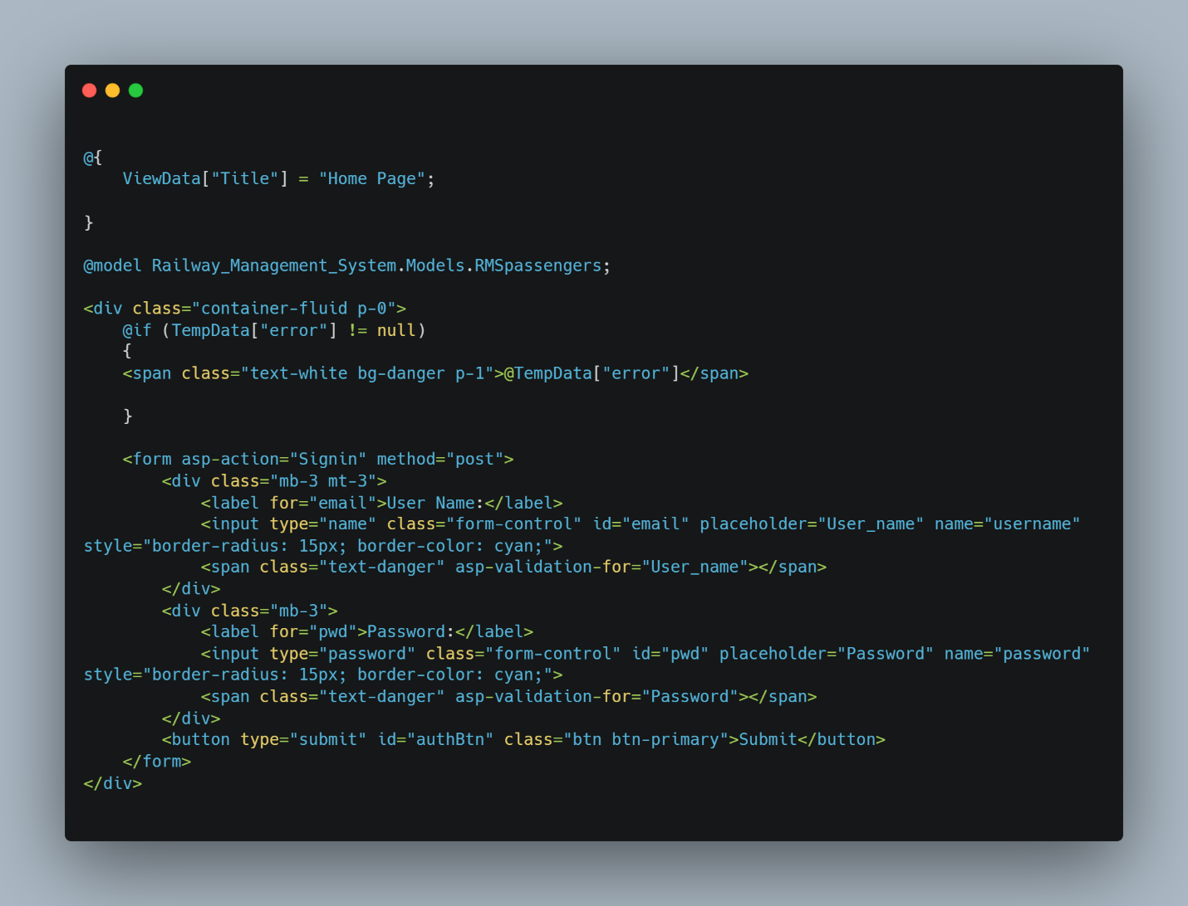

Sign in Page

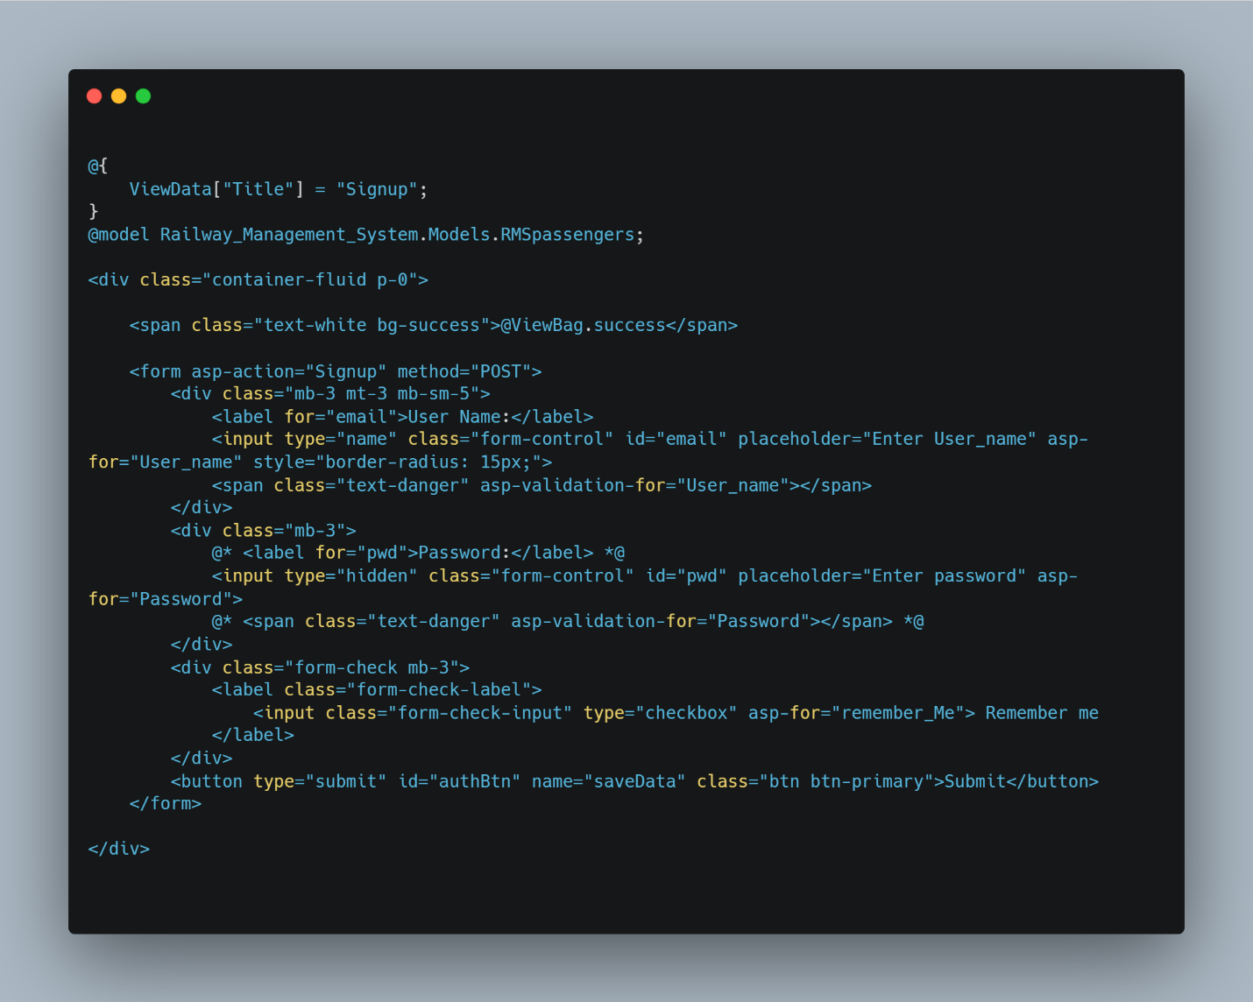

Sign up Page

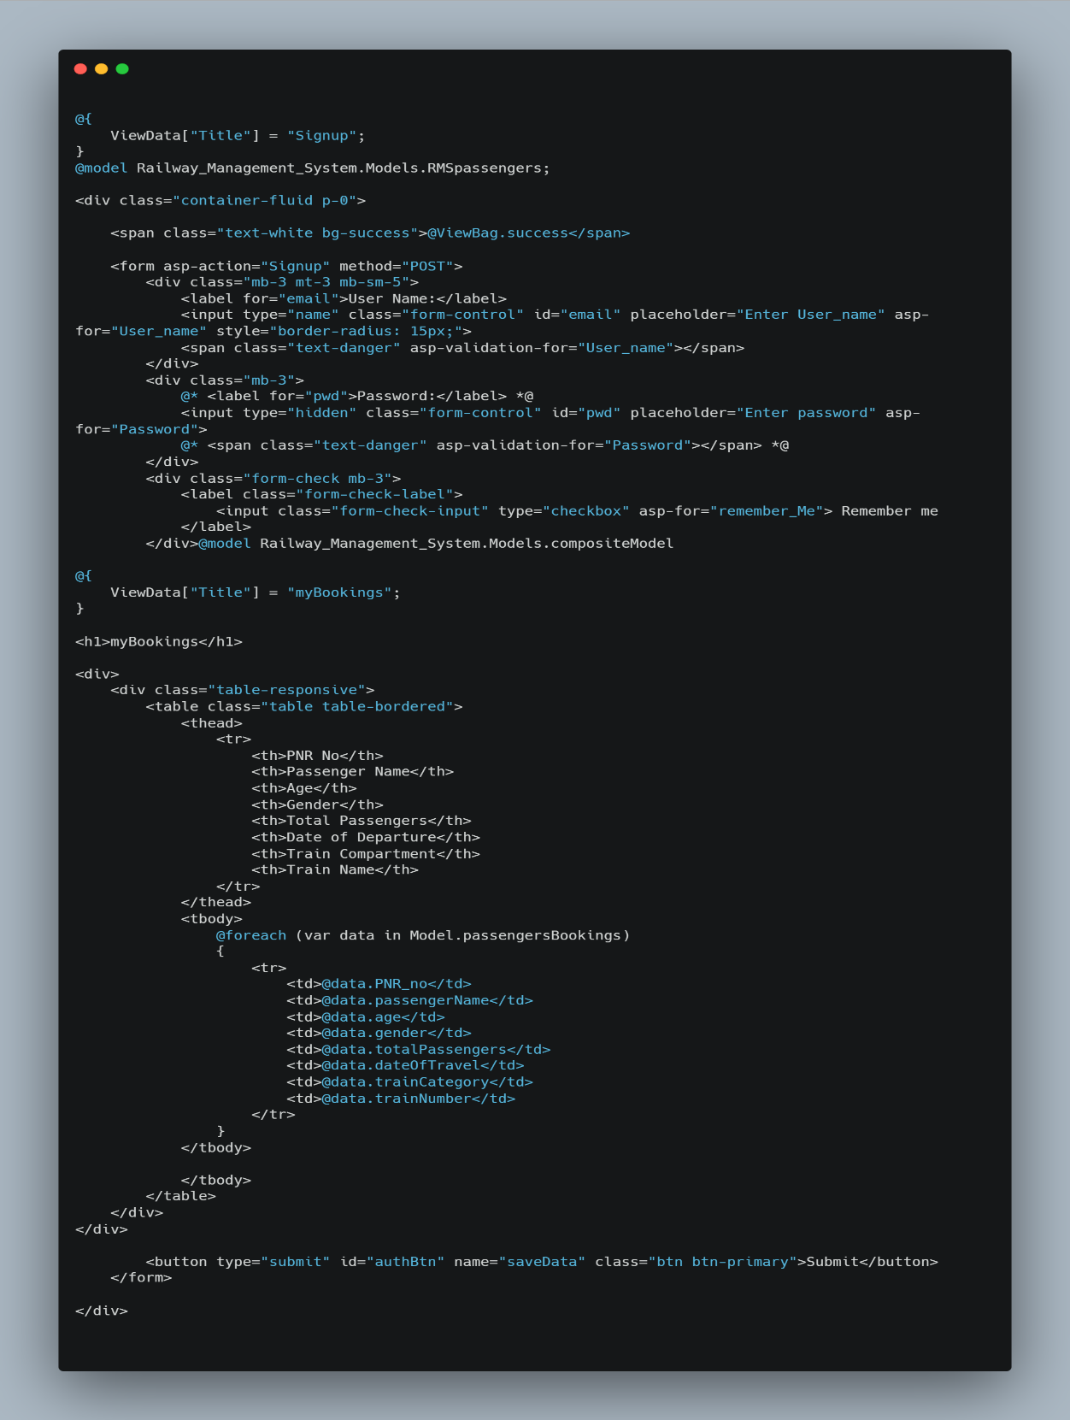

Bookings layout table

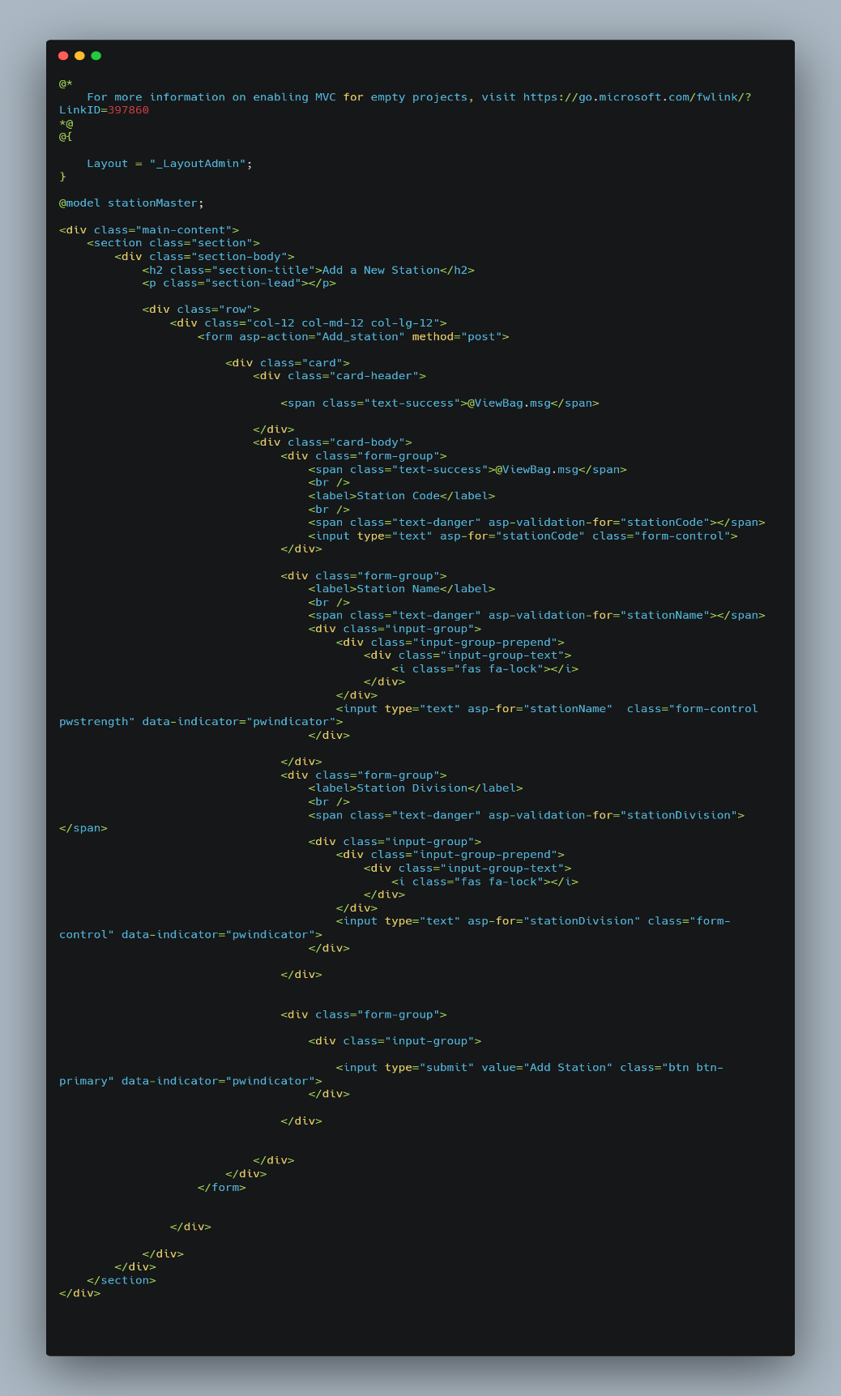

Add train Form via Admin Panel

